**Virtual Voice Assistant Using Python**

A mini-project report submitted for

## Artificial Intelligence(Semester VII)

by

Smith Dabreo (8382)

Shaleel Rodrigues (8423)

Valiant Rodrigues (8424)

Under the guidance of

Prof. Supriya Kamoji

(sign with date)



**Approval Sheet**

**Project Report Approval**

This Project entitled Virtual Voice Assistant Using Python by Smith Dabreo, Shaleel Rodrigues and Valiant Rodrigues is approved as mini project in subject ‘Artificial Intelligence’, Semester VII , Information Technology.

Examiners

1.——————————

2.——————————

Date:

Place:

**Abstract**

AI Virtual Voice Assistant can assist individuals in doing day to day tasks easily without even touching the device. In can search Wikipedia and open websites which actually interacting with user by talking to them. This gives personal feel towards using a program and users feel comfortable and safe using it.

Add various features like random jokes and facts and other interesting stuff.

## Table of Content

|  |  |  |
| --- | --- | --- |
| Chapter no. | Topic | Page no |
| 1 | Introduction | 5 |
| 2 | Problem statement | 6 |
| 3 | Scope and Relevance of  system | 7 |
| 4 | Applications | 8 |
| 5 | Methodology | 9 |
| 6 | Software and Implementation | 11 |
| 7 | References | 22 |

**Chapter 1**

**Introduction**

An intelligent virtual assistant (IVA) or intelligent personal assistant (IPA) is a [software agent](https://en.wikipedia.org/wiki/Software_agent) that can perform tasks or services for an individual based on commands or questions. Sometimes the term "[chatbot](https://en.wikipedia.org/wiki/Chatbot)" is used to refer to virtual assistants generally or specifically accessed by [online chat](https://en.wikipedia.org/wiki/Online_chat). In some cases, online chat programs are exclusively for entertainment purposes. Some virtual assistants can interpret human speech and respond via synthesized voices. Users can ask their assistant's questions, control home automation devices, and media playback via voice, and manage other basic tasks such as email, to-do lists, and calendars with verbal (spoken?) commands.

         A virtual assistant, also called an AI assistant or digital assistant, is an application program that [understands natural language](https://searchenterpriseai.techtarget.com/feature/Natural-language-processing-drives-conversational-AI-trends) voice commands and completes tasks for the user. Such tasks, historically performed by a personal assistant or secretary, include taking dictation, reading text or email messages aloud, looking up phone numbers, scheduling, placing phone calls, and reminding the end-user about appointments. Popular virtual assistants currently include Amazon [Alexa](https://whatis.techtarget.com/definition/Alexa-Voice-Services-AVS), Apple's [Siri](https://searchmobilecomputing.techtarget.com/definition/Siri), [Google Assistant](https://whatis.techtarget.com/definition/Google-Now), and Microsoft's [Cortana](https://searchenterprisedesktop.techtarget.com/definition/Cortana)

         In this project, we take advantage of all the modules and libraries provided by Python 3 to develop a well-integrated solution for everyone’s needs. This project benefits from python’s ease of usability and high scalability. We can automate the various day-to-day task and they are just one sentence away from being executed. Our virtual assistant can be scaled to any extent and only sky is the limit. It can be used to serve a common assistant purpose or can be transformed to delve into various other domains and can be modified as per specific fields, for instance, it can become an assistant for mental health or an assistant for ordering food at a restaurant, etc.

**Chapter 2**

**Problem Statement**

Develop a Virtual voice assistant for performing and automating daily tasks using python. The assistant should be scalable and easy to use and interact appropriately with the user.

**Chapter 3**

**Relevance And Scope Of System**

**Relevance**

For most of us, the ultimate luxury would be an assistant who always listens for your call, anticipates your every need, and takes action when necessary. That luxury is now available thanks to artificial intelligence assistants, aka voice assistants.

Voice assistants come in somewhat small packages and can perform a variety of actions after hearing a wake word or command. They can turn on lights, answer questions, play music, send emails, etc.

Voice assistants are not to be confused with virtual assistants, which are people who work remotely and can therefore handle all kinds of tasks. Rather, voice assistants are technology based. As voice assistants become more robust, their utility in both the personal and business realms will grow as well.

**Scope**

Technology is constantly advancing and changing, and the voice assistant market will progress along with it. In April 2015, the research firm Gartner predicted that by the end of 2018, 30 percent of interactions with technology would be through “conversations” with smart machines, many of them by voice and it was even more that that by the end of that year.

According to [Global](https://gminsights.wordpress.com/tag/virtual-assistant-industry-statistics/) Market Insights, Inc., between 2016 and 2024, the market share for the technology will grow at an annual rate of almost 35 percent. More and more sectors of the economy, like healthcare and the automotive industry, are finding uses for the speech recognition technology in addition to those found in devices like smart speakers and phones.

Some key future scopes are:

* Excellent compatibility and integration
* Change in search behaviour shift towards voice searches
* Individualized experience
* Automate upto 100% of the tasks
* Stronger Data security
* Advancement in Voice User Interface(VUI)
* Effective AI assistants

**Chapter 4**

**Applications**

Virtual Voice assistant can help individuals in performing tasks such as:

* Opening various websites just by speaking (e.g. sites: google, YouTube, twitter, etc).
* It is available 24x7 and just one click away.
* Return date and time very quickly
* Access the whole Wikipedia.
* Play music whenever you ask.
* Open various applications without even the user touching the PC
* Email people on your behalf without even user typing a word.
* Tell random jokes and facts to keep people entertained.
* Keep on expanding and evolving without any limits.

**Chapter 5**

**Methodology**

Methodology can be divided into two parts knowledge abstraction and response generation. Knowledge abstraction has to do with the analysis of content (which we will call data). On the other hand, response generation depends on the characteristics of the data generated in the process of knowledge abstraction. In addition to that, it depends on various features and modules provided by python and its various integrations.

**5.1 Knowledge abstraction**

Knowledge abstraction involves three phases: gathering, manipulation and augmentation. These phases are mostly independent from the content of the voice assistant.

Data gathering:

The first step is to generate a knowledge base. This step involves finding key concepts and gathering information about them.. Then, one has a bunch of questions. These questions might come from online records (such as discussion forums, social media interaction with students or messaging applications). After this process, developers can then classify this questions in categories according to the topic they relate to. These categories structure the content of the voice assistant:

Data manipulation:

The second step, This will enable developers to manipulate data. the set of questions found in a discussion forum together with their answers. Then, they can classify each question with its corresponding topic by looking for the keywords within the question or the answer strings. This consists technically in the implementation of a classification algorithm that labels each question answer pair. These labels must be given a degree of confidence and then checked by a human to confirm its validity. All the keywords are needed to be specified for developing a well-integrated and well-functioning program. This voice data needs to be converted into text for the program to understand and match the labels to give appropriate answers and carry on the conversation.

Data augmentation:

Data manipulation can be taken to another level by introducing data augmentation. Here the program can be introduced with new keywords so it can understand the user better and enhance the quality of voice communication. Also the program can be provided with variety of keywords for keeping the users interested and surprising them with something new once in a while. Keywords can be modified as per users variety of features can be included to give numerous features at the users disposal.

**5.2 Response generation**

Generation of appropriate responses plays a major role in the execution of a voice assistant the better the responses are the better they sound when an AI talks about them. They are the building blocks of the voice assistant markets as the provide the personal fell which chat bots cannot provide and make voice assistants very easy to use as well as make them efficient. A through study on various can be done of users to improve responses so that the users can enjoy talking to voice assistants more. Variety of responses can be added as per the question and as per the conditions to ameliorate the feel to it. Various python modules can be installed and incorporated to include more and more features

**Chapter 6**

**Software and Implementation**

We have used various python modules for including numerous feature and the google speech recognition module for better performance and accuracy.

Screenshots of the implementation are attached here

Various tasked performed by the voice assistant:

1. Opening various websites ( YouTube, Twitter, etc)

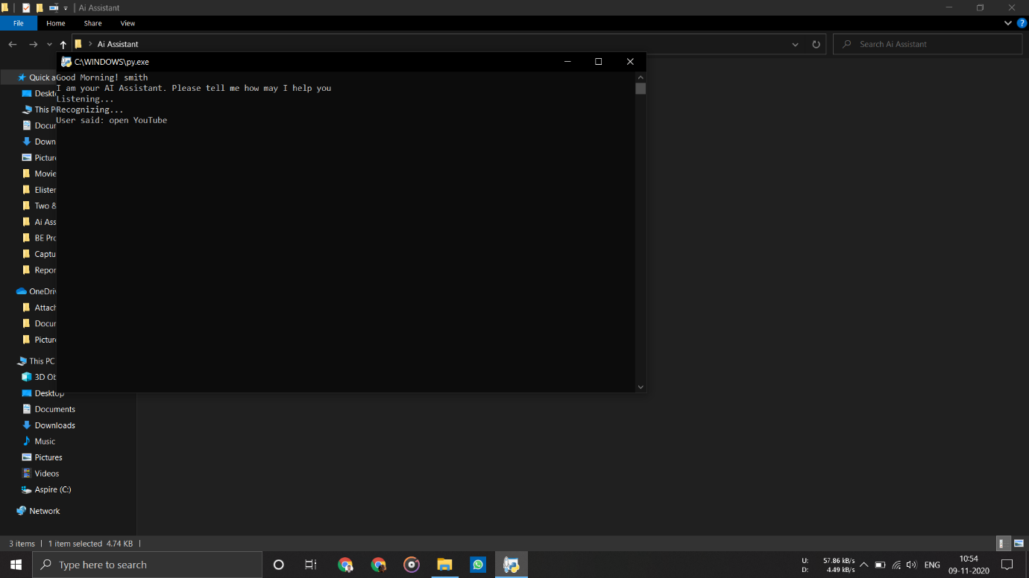

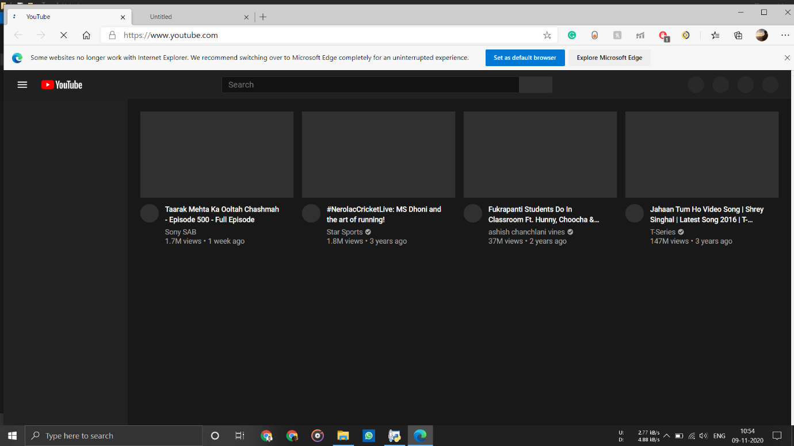

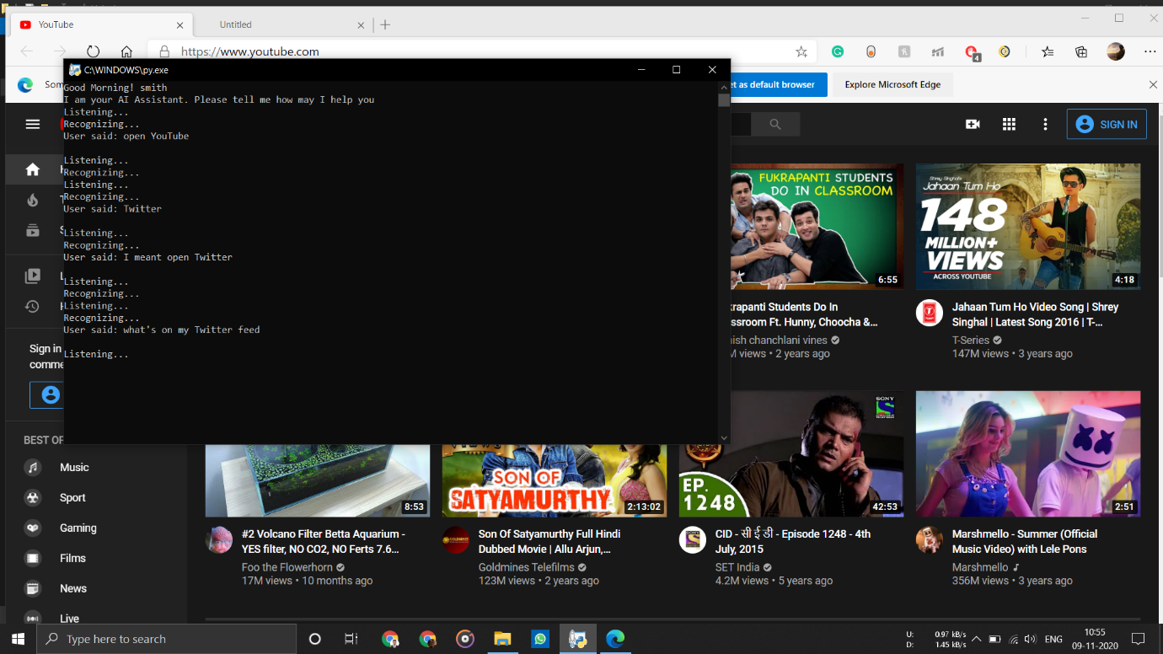

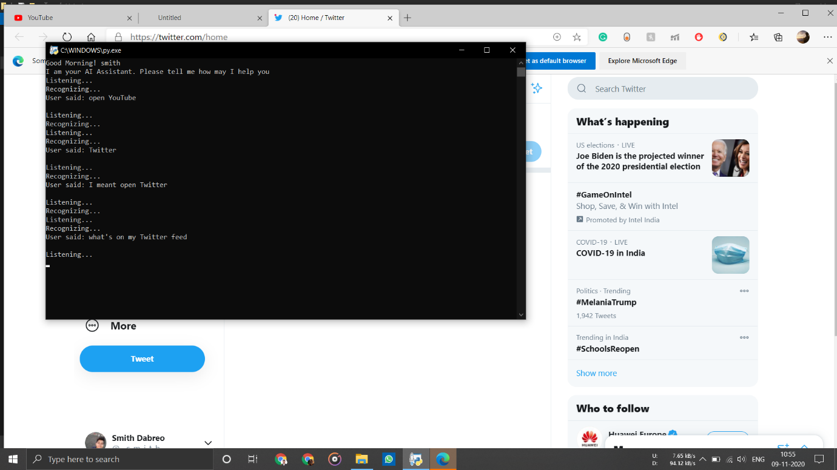

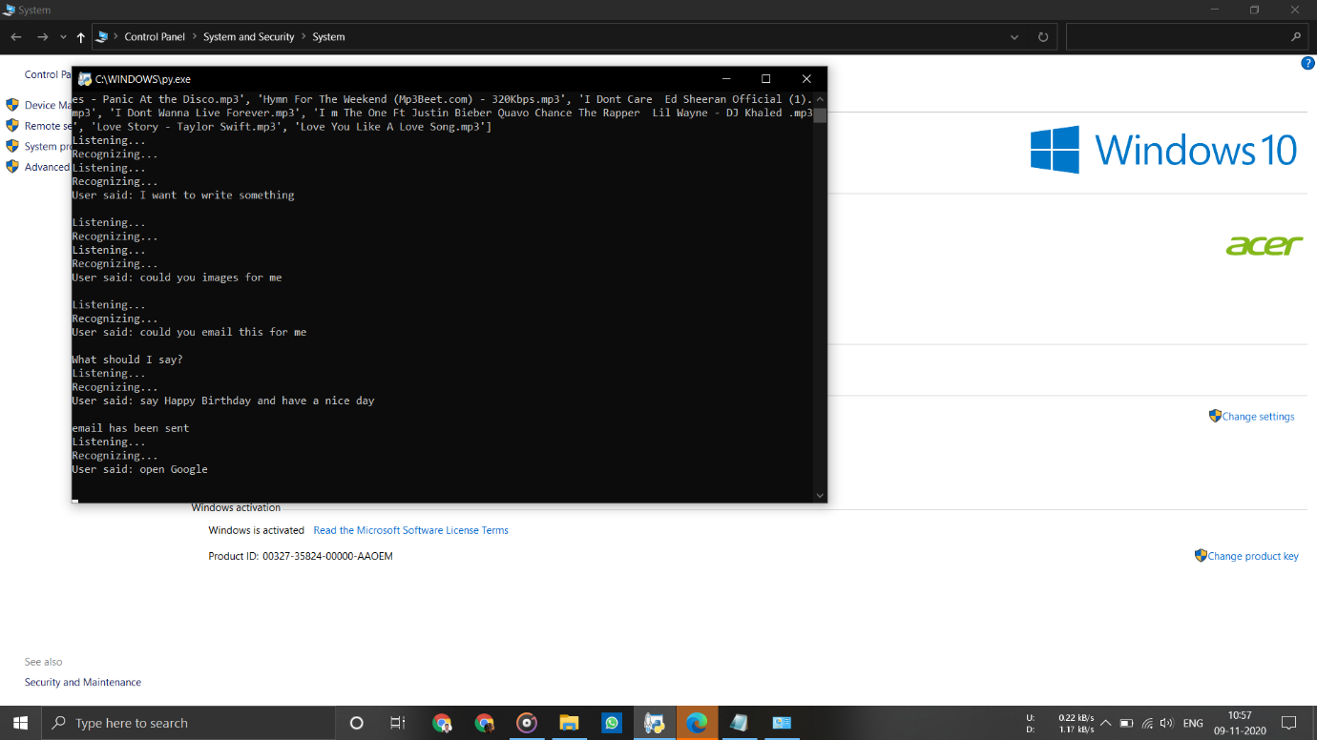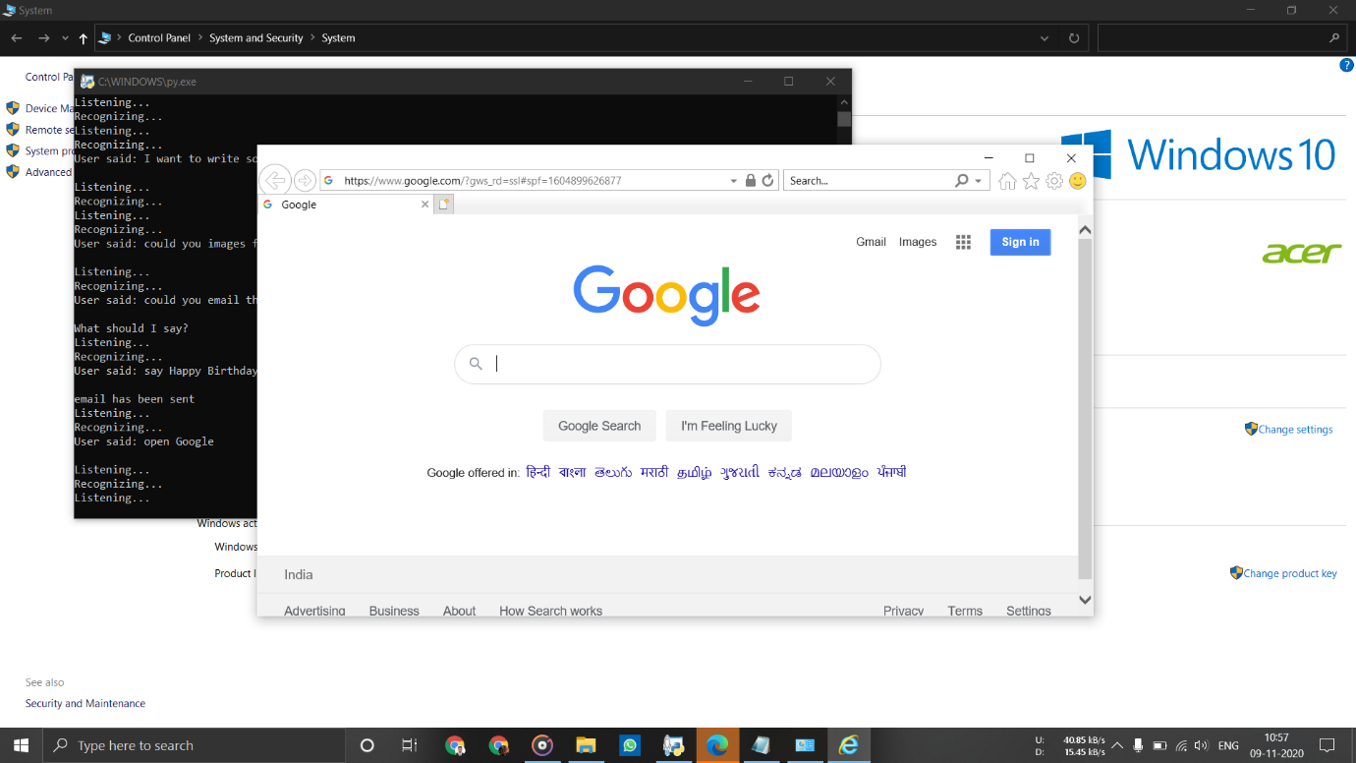

1. Telling Random Jokes and Facts

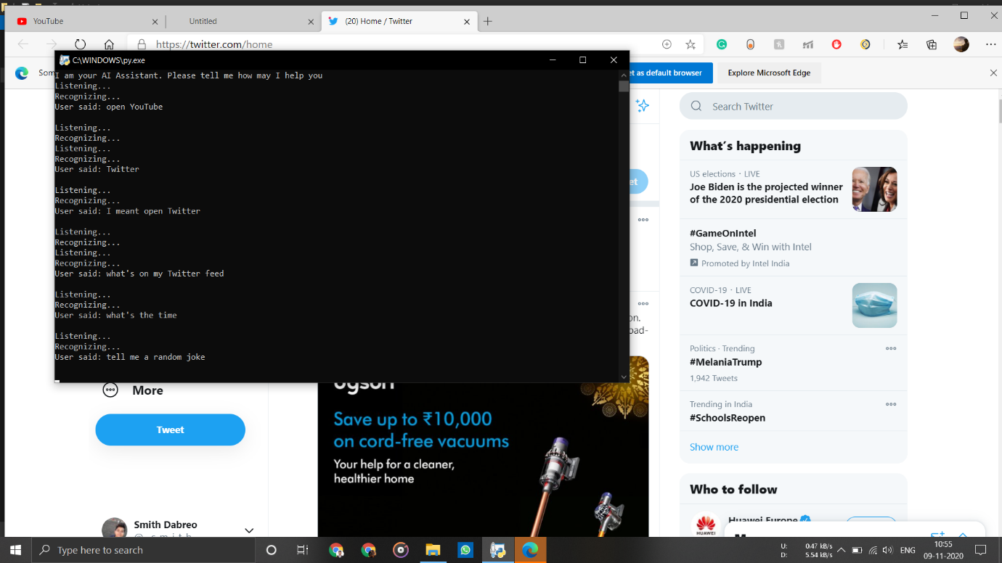

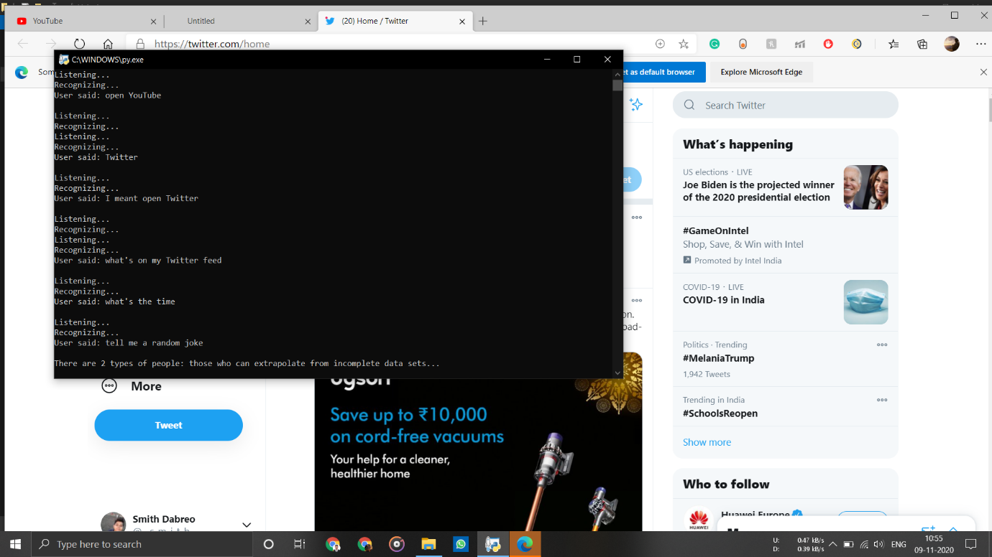

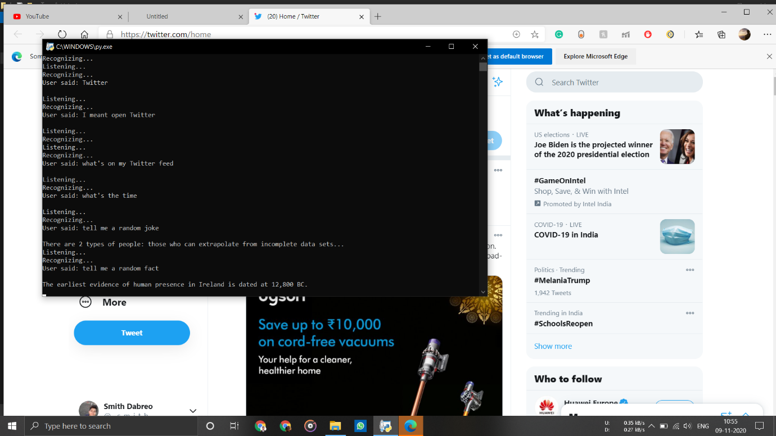

1. Playing Music

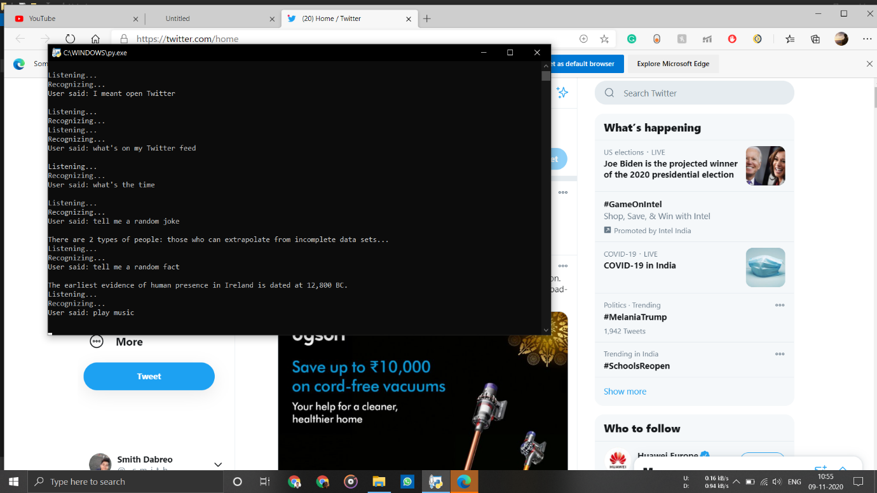

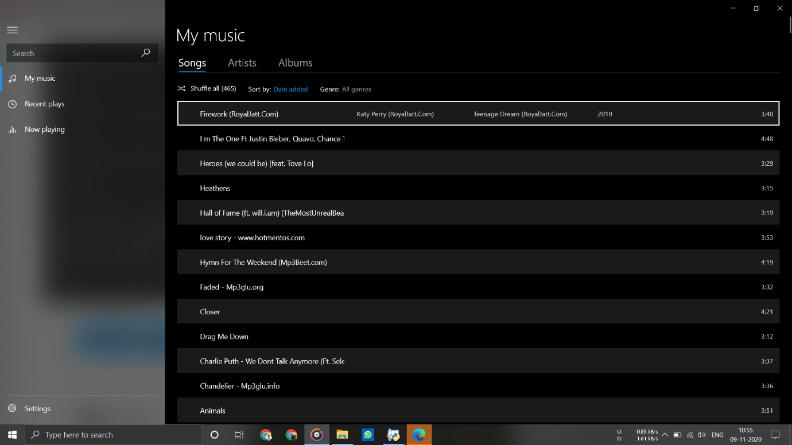

1. Opening Windows apps

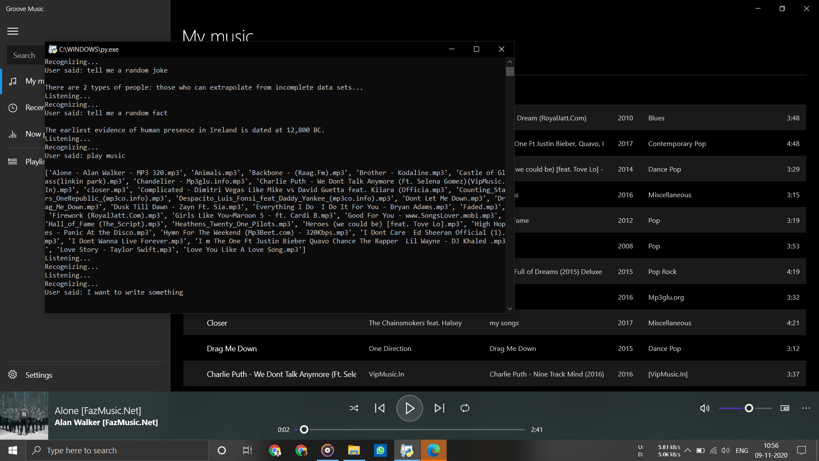

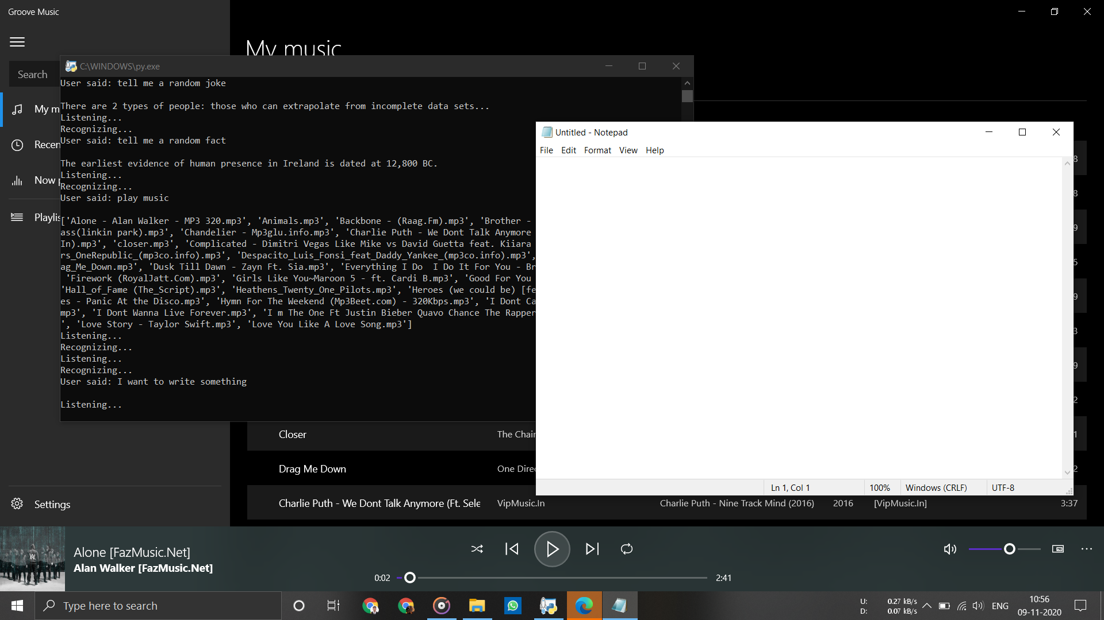

1. Emailing People

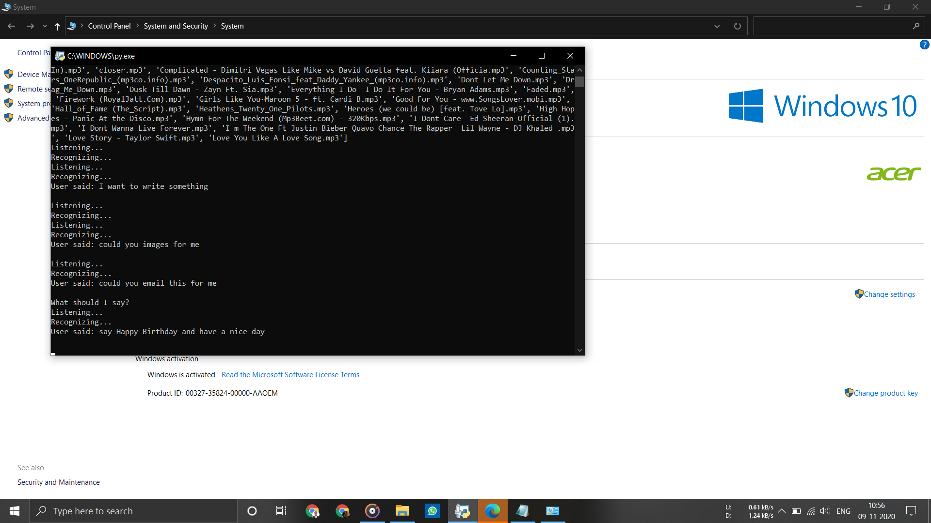

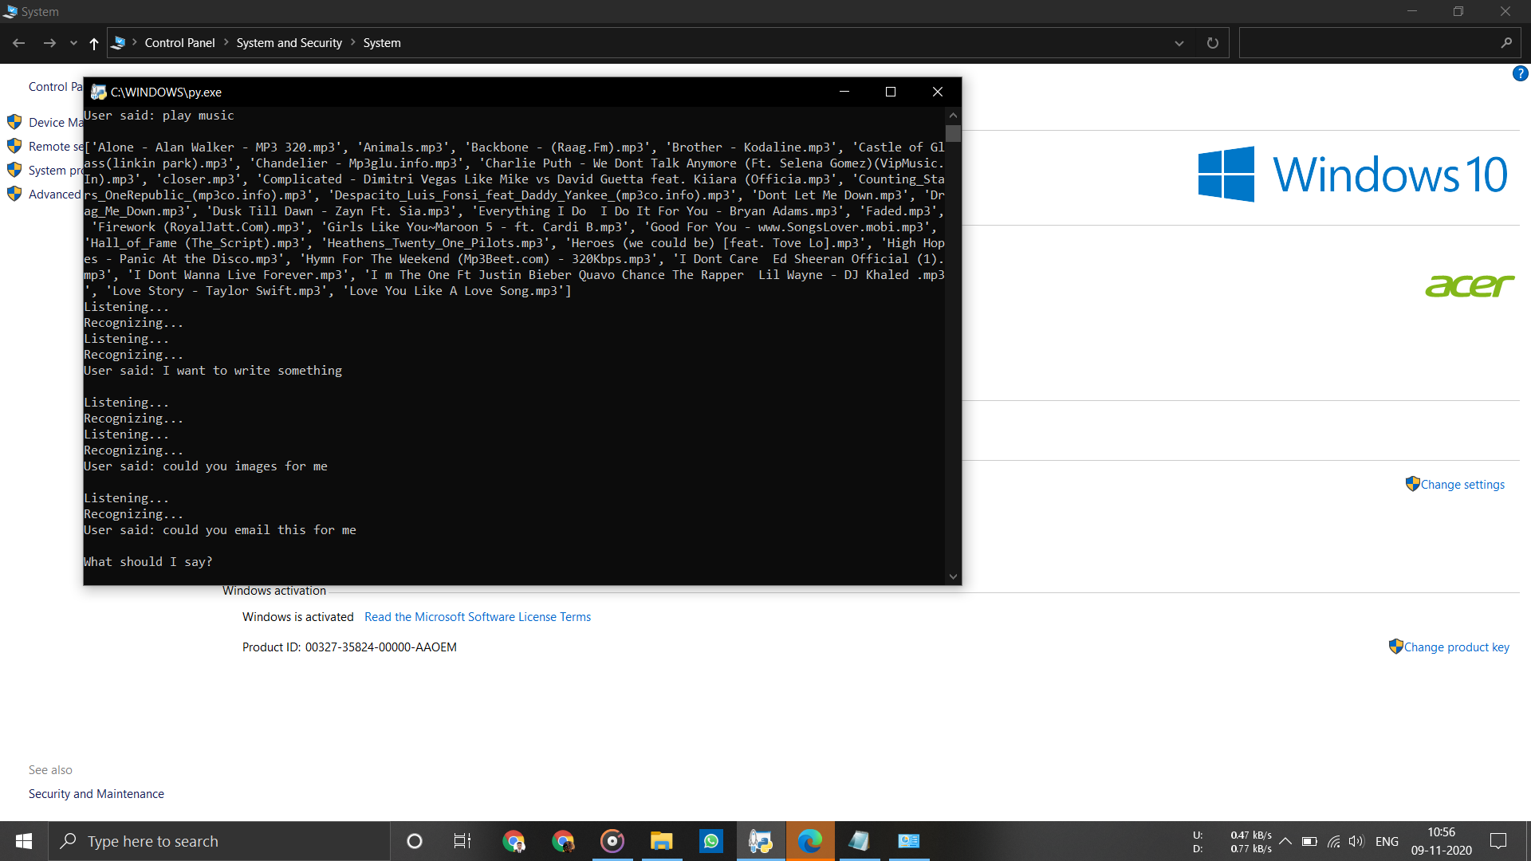

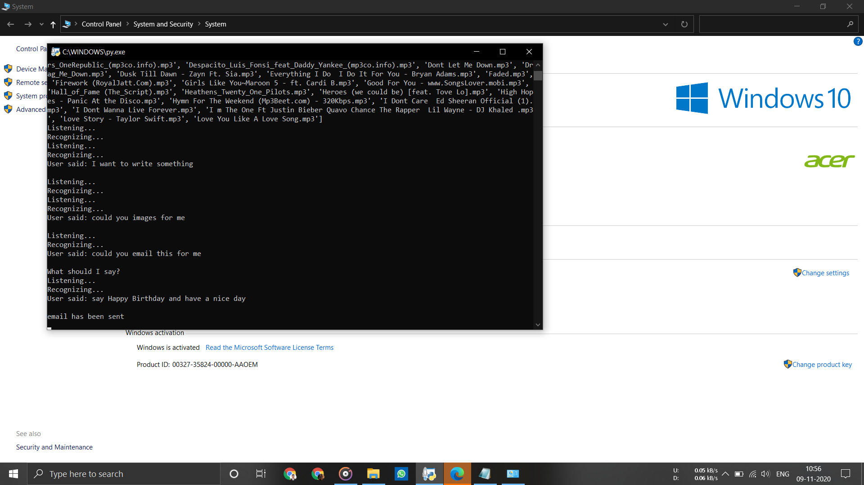

1. Using Wikipedia

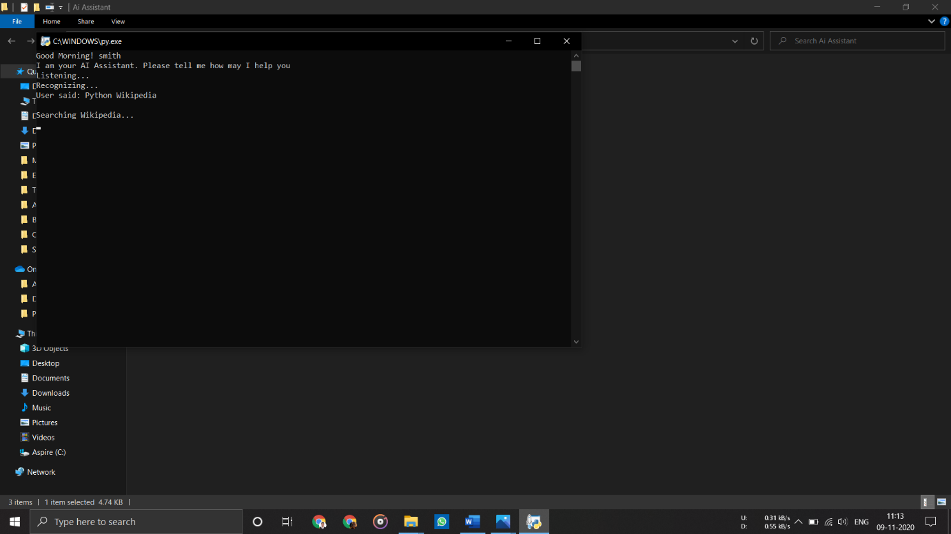

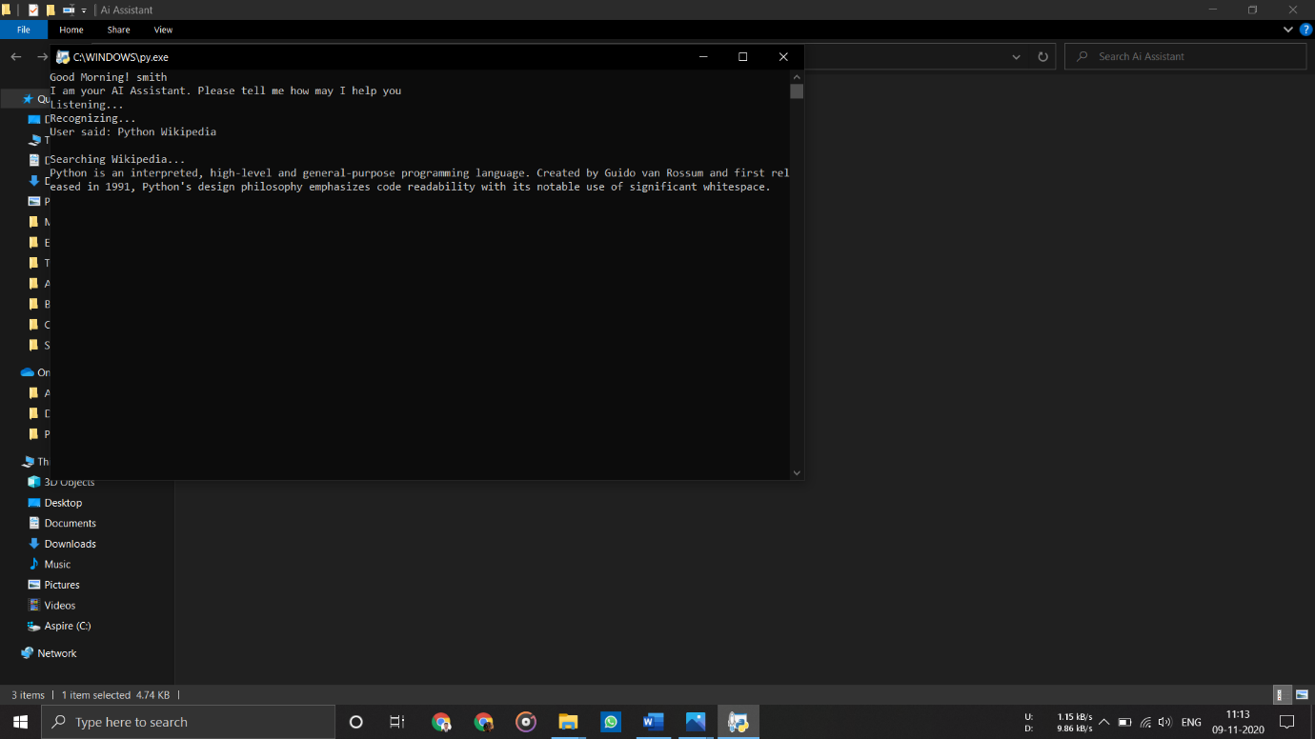

1. Exiting

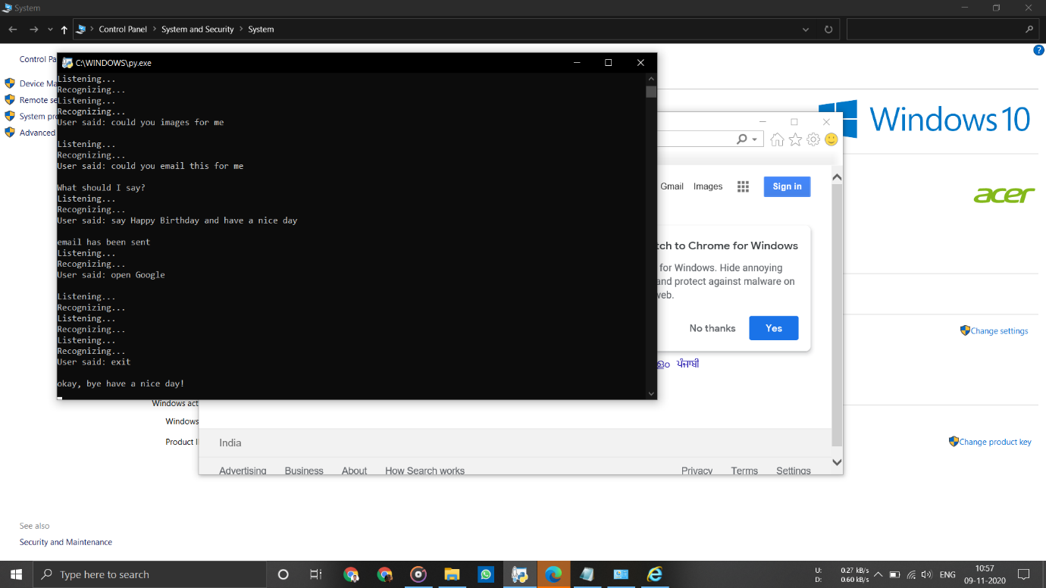

Chapter 7

References

1. <https://docs.python.org/3/library/>

2. AI-Smart Assistant Tushar Gharge1, Chintan Chitroda 2, Nishit Bhagat3, Kathapriya Giri4, jan 2019

3. A Study on Virtual Assistant in Artificial Intelligence Neeta Takawale1 , Shibani Kulkarni1 , Deepashree Mehendale1 , Reshma Masurekar1 , Shweta Agarwal2 Asst. Professors, Department of Computer Science, Dr. D. Y. Patil ACS College, Pune, India1, Sept 2017

4. SIRI – APPLE’s PERSONAL ASSISTANT: A REVIEW Bisma Shakeel1 , Tabasum2 , Mir Shahnawaz Ahmad3, July 2017

5. ML Based Virtual Personal Assistant [1] V.Lalitha, [2] A.Dinesh , [3] L.Parameswaran, [4] S.Dinesh Kumar, July 2019